**DAY 4 ASSIGNMENT**

**SUBMITED BY D.SARAVANA**

1. **mail server information of IBM.COM**

ibm.com MX preference = 5, mail exchanger = mx0a-001b2d01.pphosted.com

ibm.com MX preference = 5, mail exchanger = mx0b-001b2d01.pphosted.com

* 1. mail server information of WIPRO.COM

wipro.com MX preference = 0, mail exchanger = wipro-com.mail.protection.outlook.com

wipro-com.mail.protection.outlook.com internet address = 104.47.124.36

wipro-com.mail.protection.outlook.com internet address = 104.47.125.36

1. **my email traced source of email server location in the below.**

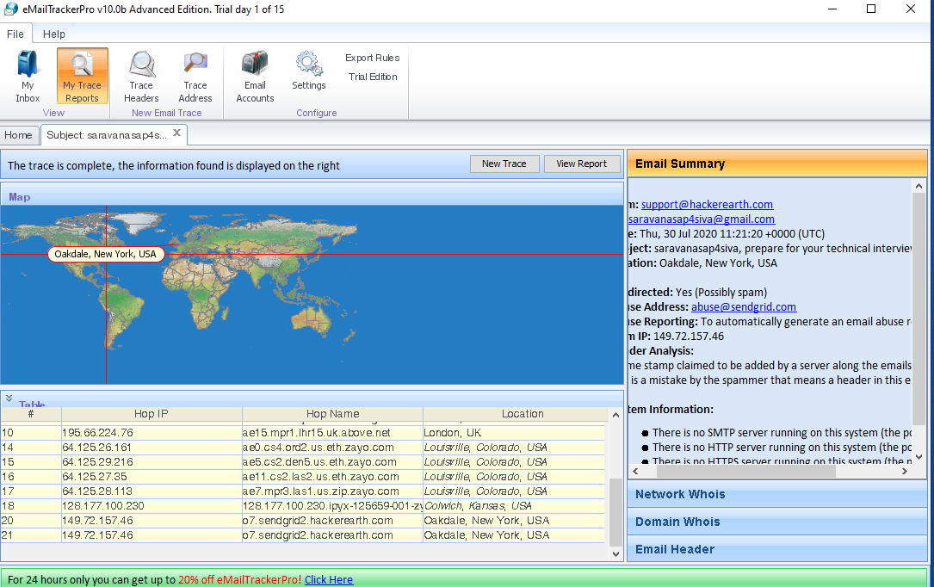

2.1 IBM mail server location trace information.

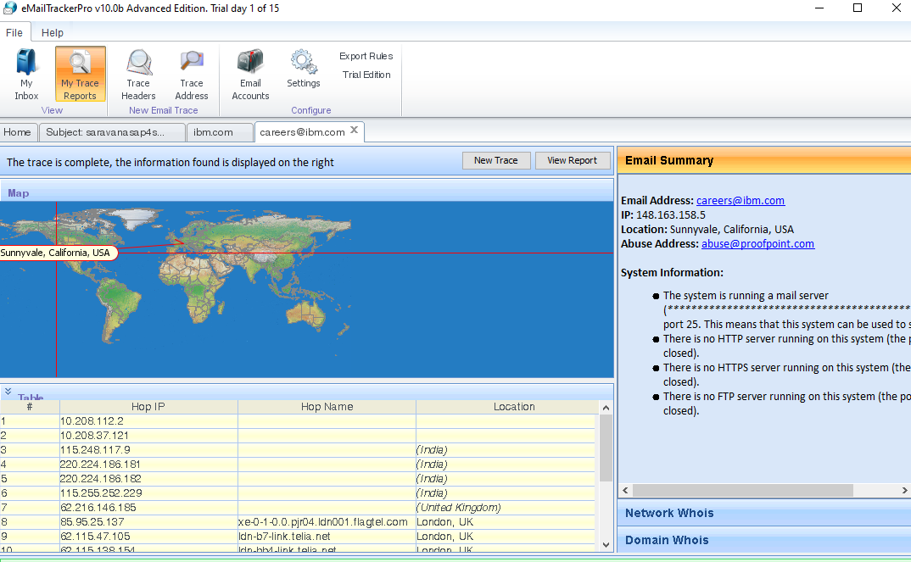

**2.2 WIPRO MAIL SERVER LAOCATION INFORMATION**

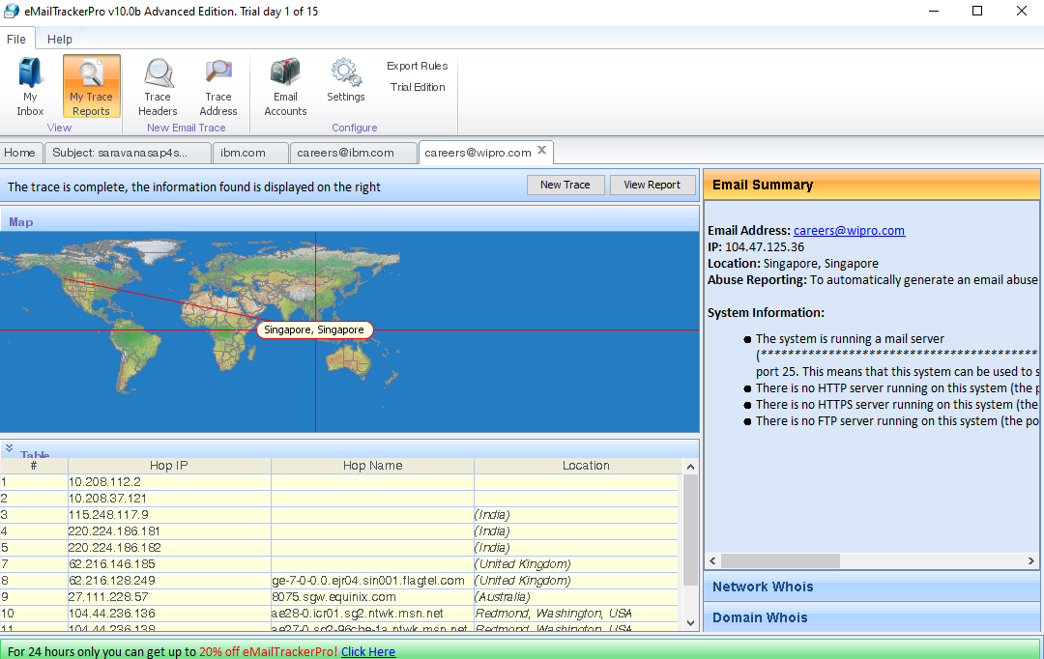

1. SCANNING OF OPEN PORT IN PUBLIC IP 203.163.246.23.

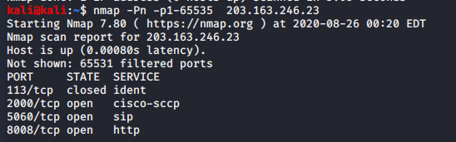

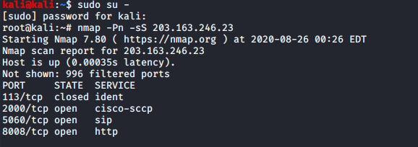

1. **SCANNED RESULT OF DOMAIN CONTROLLER USING NESSUS ESSENTIAL SCANNER and its vulnerability Reports.**

